Microeconomics Group Assignment 4
Fogel Study Group 1
Nowa Imasekha
Chen Fengqiao
Shu Tang
Shori Ando
Oran Aviv
Derrick Teo

Q50
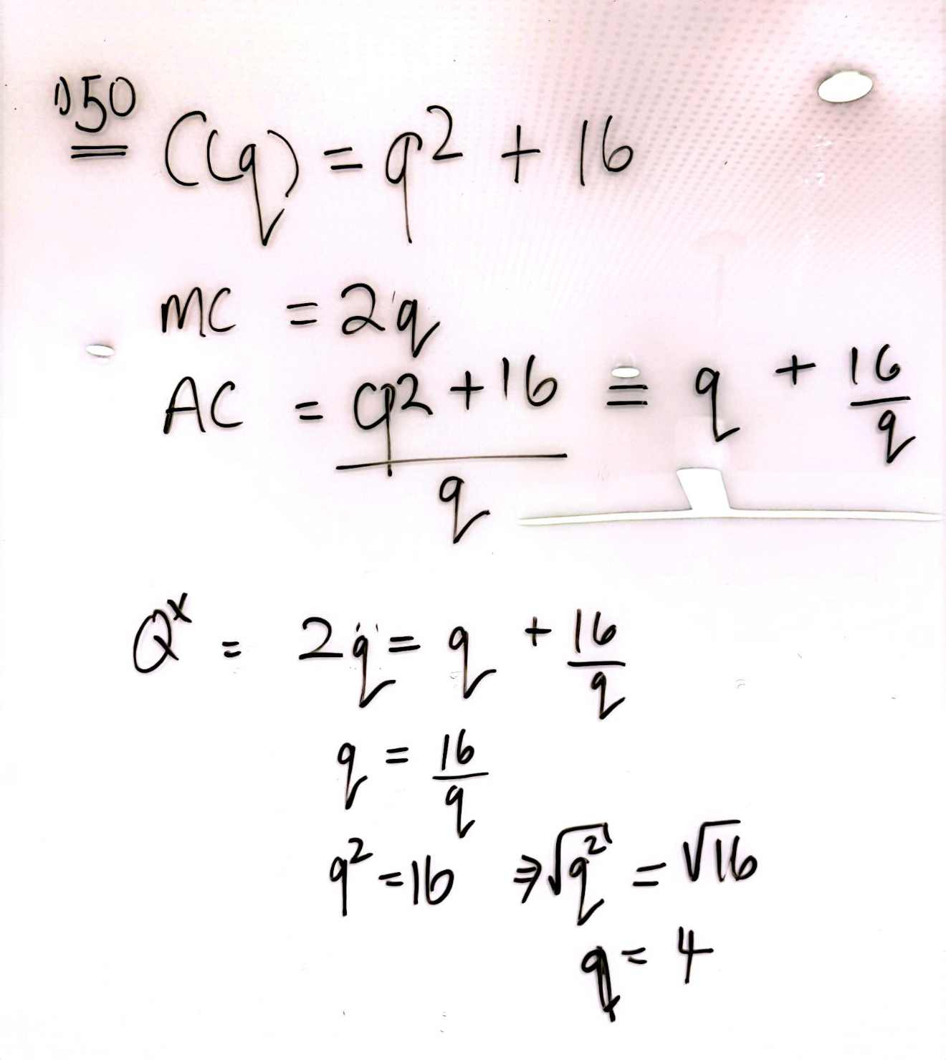
Q53
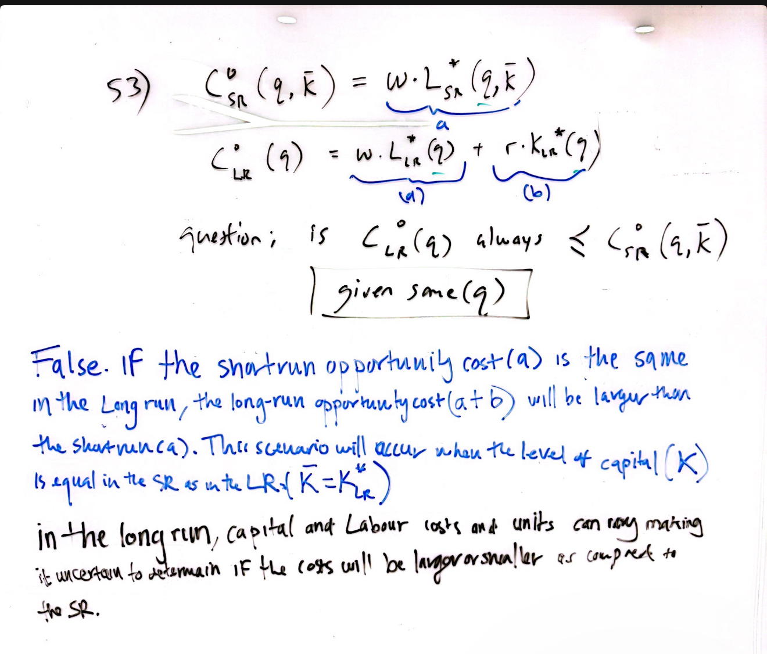

Q65

